SAMHSA SOAR TA Center
soar@prainc.com
Abstract
This toolkit will help you to develop a SOAR referral process for your community or
agency that helps ensure that potentially eligible individuals are connected
with SOAR-trained providers that are available to assist.
SOAR Referral Process
Workflow Toolkit

Contents
SOAR Referrals Workflow Packet Product Guide 2
SOAR Agency and Community Assessment 3
SOAR Marketing Tool 4
[Your Agency] SOAR Referral Process 5
SOAR Referral Application 6
Applicant Resource Guide 9
Referral Tracking Spreadsheet 10

SOAR Referrals Workflow Packet Product Guide

SOAR Agency and Community Assessment
The Agency and Community Assessment tool can help SOAR providers determine who is most likely to send referrals, which agencies/departments need SOAR marketing information, and who can assist potential applicants who are not eligible for SOAR services within your agency. We recommend completing these assessments prior to editing your referral process tools.

SOAR Marketing Tool
SOAR providers can customize this marketing tool to highlight their program criteria, SOAR outcomes, and guidance on making appropriate referrals. Make sure to edit the information in all sections of this infographic to fit with your agency. In the highlights section, feel free to change up the information to market what makes your SOAR program stand out. Creativity is encouraged with this tool!

Agency SOAR Referral Workflow
This workflow is useful for walking SOAR providers through each step of the referral process. Direct links are provided throughout the workflow to guide users to forms and resources that will be used throughout the referral process.

Sample Referral Application
The Sample Referral Application is a great tool to use as a template for your own agency’s SOAR referral process. Be sure to make appropriate edits; we want this form to fit with your agency’s SOAR program.

Applicant Resource Guide
All good referral systems need a back-up plan! Customize this resource guide to assist potential applicants who are not eligible for SOAR at your agency. Make sure to include contact information for each source provided on this form.

Referral Tracking Worksheet
The tracking worksheet will help you keep track of the quantity and quality of referrals from agencies throughout your community. Tracking your referrals will help to identify where your best referrals are coming from and which agencies need some guidance on making appropriate referrals.

SOAR Agency and Community Assessment
In order to create effective SOAR marketing and referral tools, we must have strong foundational knowledge of SOAR in your agency and within the community. This assessment will help guide your intentions as you work through creating a strong referral system. If you do not know the answer to a question, research it! The information collected in this assessment will be used to create a referral system that works where you do.

Agency Assessment
- Who is providing SOAR services in your agency?
- What are the agency criteria to receive SOAR services?
- If more than one case worker in your agency is providing SOAR services, do the eligibility criteria vary between providers?
- How many in-agency referrals do you receive per month?
- Where are your referrals coming from?
- Are there any other teams or case workers who serve SOAR eligible people, but are not making SOAR referrals?
- What happens when you receive a SOAR referral from within your agency and the person does not meet program criteria?
- What strategies and efforts does your agency implement to reduce racial disparities in service delivery?

Community Assessment
- Do you accept outside referrals?
- What agencies provide SOAR services in your community?
- What agencies refer potential SOAR applicants to you?
- How do you currently receive referrals from other agencies?
- Is SOAR part of coordinated entry in your CoC?
- Are there any agencies that serve likely SOAR-eligible people who are not making referrals?
  - If yes, what agencies?
- What happens when someone is referred for SOAR services from another agency, but is not eligible for your SOAR program?
- What other programs/agencies provide SSI/SSDI assistance?
  - Legal Aid?
  - Law Schools?
  - Advocacy programs?
  - Churches?
  - Other?
- What happens if a SOAR applicant is denied for SSI/SSDI on the initial application?
- What other agencies in your community, particularly those who serve divers populations, need to know about SOAR?
SOAR State and Agency logos here:
over $600,000 in back pay and monthly benefits

$600,000

assistance to over 50 eligible adults

50

42 families were connected with disability benefits

42

SSI/SSDI Outreach, Access, and Recovery (SOAR) is a national program designed to increase access to the disability income benefit programs administered by the Social Security Administration (SSA) for eligible adults and children who are experiencing or at risk of homelessness and have a serious mental illness, medical impairment, and/or a co-occurring substance use disorder.

SAMPLE LANGUAGE: Eligible referrals must be a veteran or military spouse, have a confirmed medical impairment or mental illness that prevents gainful income, and be experiencing or at risk of homelessness.
Make a referral and contact SOAR! | EMAIL: info@xyz.com | PHONE: (555) 555-5555 | WEBSITE: https://www.xyz.com
Enter detailed instructions for making a referral here…
2021
PROGRAM HIGHLIGHTS
HOW TO MAKE A REFERRAL
WHO IS ELIGIBLE
WHAT IS SOAR?
XYZ COMMUNITY MENTAL HEALTH

[Your Agency] SOAR Referral Process
Case Workers trained in the [Your Agency] SOAR process are expected to complete the following steps. This process is meant to facilitate SOAR referrals that are appropriately submitted and screened. Fidelity to this process will help to ensure equitable access to SOAR services along with strong outcomes.

Step One: Receive Referral
- Referring sources should utilize the SOAR Referral Tool or the [Your Agency] SOAR Referral Form.
- Contact potential applicant to complete the Identifying SOAR Applicants document.
- If determined to be an appropriate referral, schedule an intake meeting with the applicant.
  - For assistance determining an appropriate referral, please contact your SAMHSA SOAR TA Center Liaison (find direct link to your state at https://soarworks.samhsa.gov/directory).

Step Two: Determine Referral Disposition
- If an appropriate referral:
  - Prioritize and add to waitlist
  - Consider racial disparities when prioritizing your waitlist
- More information needed:
  - Contact referral source for more information
  - Request additional records to verify diagnoses
- If not eligible for [Your Agency] SOAR Program:
  - Follow up with referral for additional options
  - Provide list of SSI/SSDI Resources in your community
  - Refer to vocational rehabilitation or other local programs that may be able to assist with employment and housing

Step Three: Follow up with Referral Source
- Communicate with referral source on:
  - Quality of referral
  - Program Eligibility
  - Prioritization of Application
  - Additional Documentation needed

Step Four: Complete the SOAR Application Process
- Using the SOAR Process Workflow for your state, complete the application

Step Five: Track Your Referrals and Outcomes
- Use the [Your Agency] SOAR Referral Tracking Worksheet to track your referral
- Enter the outcomes of all your SOAR-assisted applications into the SOAR Online Application Tracking (OAT) system (https://soartrack.samhsa.gov/).

SOAR Referral Application
Please complete in full and fax to: [Contact Name] at [Fax #]
Candidate Name: |  |  | Date of referral:
Referring agency: |  |  | Person making referral:
Staff contact number: |  |  | Email address:

Candidate Identifying Information:
Date of birth: |  |  |  |  | Gender: |  | Pronouns: |  |  |  |  | Race:
(must be within 30 days of 18 years of age, or within 180 days if exiting foster care)
SSN: |  |  |  | Education (last grade completed): |  |  |  |  |  | Marital Status:
Current living arrangement (address, shelter, area of town):
Employment status: |  |  |  |  |  |  |  | Veteran?
Emergency contact name and number:

Part A: Homelessness/At-Risk Assessment
Where is the candidate currently living? Check the appropriate selection
Experiencing Homelessness | “X” |  | At-Risk for Homelessness | “X”
Outdoors |  |  | Doubled up/couch-surfing
Shelter |  |  | Received eviction notice or has substantial arrears in rent/utilities
Transitional Housing |  |  | Permanent supportive housing that is grant funded (Housing First placements)
 |  |  | Exiting foster care
 |  |  | Institution – hospital, nursing home, etc.
 |  |  | Jail

How long has the candidate been experiencing homelessness: |  | Years and |  | Months
Is the candidate in an institution or jail? |  | Yes |  | No
If yes, are they expected to be released within 30 days? |  | Yes |  | No
Were they experiencing homelessness before entering the facility? |  | Yes |  | No
Has the candidate had difficulty maintaining housing? |  | Yes |  | No
If yes, please describe:

Part B: Current Application for SSA Benefits or Pending Appeal
Has the candidate recently applied for Social Security benefits? |  |  |  | Yes |  | No
If yes, date of application: |  | Decision on application: |  | Pending |  | Denied
If denied, did the candidate appeal? |  |  |  | Yes |  | No
If yes, are they waiting on a decision? |  |  |  | Yes |  | No
Are they working with a lawyer? |  |  |  | Yes |  | No
Part C: Diagnostic Information
Please list all mental and physical health diagnoses:
Where has the candidate been treated for these conditions?

Current medications and prescribing physician/agency:

Does the candidate have a history of substance use? |  |  | Yes |  | No
Prior or current substance use is not a disqualifying factor for SOAR
Last substance(s) used: | Last known date of use:

Part D: Narrative questions for SOAR eligibility
Ask these questions to the candidate and record answers
1. | Can you tell me about why you are looking to apply for Social Security benefits?
2. | When was the last time you were able to work? Why did you leave that position? Can you tell me about any times you have tried to work in the past couple of years?  (If candidate is currently working): Tell me about your job: How many hours per week do you work? How much do you earn each month? Is there anything you struggle with while on the job or find difficult about your work?
3. | Tell me about any ways that your conditions make things difficult for you on a daily basis: Do you notice any difficulties with day-to-day activities? Do you have trouble getting along with others or feeling like you want to avoid people? Have you noticed any changes in your memory?
Summary and Next Steps
To assess SOAR eligibility, we are looking for basic information on:
- The presence of medical and/or psychiatric conditions or symptoms which would fit an SSA listing
- Current treatment, or a history of treatment for conditions
- Inability to work and earn SGA ($1,350/month in 2022) due to medical and/or psychiatric conditions (not because they cannot find work or were laid off)
- Impairments in functioning due to medical and/or psychiatric conditions
SOAR specialists will contact the candidate to follow up on information provided on this form. A full intake assessment may be required to gather additional supporting evidence to determine if we can assist the candidate with a SOAR application.

SOAR Referral Follow-up

Candidate Name:
Date Referral Received: |  |  |  |  |  | Date candidate contacted:
If unable to contact, list dates of contact attempts:
Notes from call/meeting with candidate:
Next Steps:
 | Intake assessment is NOT appropriate.
 | Reason: |  |  | Follow-up resources or referrals provided:
 | Candidate is eligible for intake assessment and will have:
 |  | Active placement. Initial appointment for screening scheduled for:
 |  | Waitlist placement. Initial appointment to be scheduled at a later time.
SOAR Staff Signature |  |  |  |  | Date

Applicant Resource Guide
This guide is meant to provide additional community resources for applicants who are not eligible for SOAR services at [Add Your Agency Name Here].

Low- or No-Cost Legal Representatives
- Update all of the following information with local resources:
- Legal Aid Clinic
  - Phone:
  - Email:
- Local University Law Program
  - Phone:
  - Email:
- Pro-Bono Attorneys
  - Phone:
  - Email:
- Local Bar Association
  - Phone:
  - Email:

Vocational Rehabilitation and Work Centers
- Vocational Rehabilitation Program
  - Phone:
  - Email:
- Employment Center
  - Phone:
  - Email:

Other Community Programs
- Department of Human Services
  - Contact information
- Community Mental Health
  - Contact information

Other Attorneys
- Name of Firm
  - Contact Information

Local SSA Office
- Contact information

Referral Tracking Spreadsheet

This Referral Tracking Spreadsheet can be used to track the content, quality, and outcomes of your referrals. Feel free to customize the data elements that you track. “Pick-lists” are provided for some of the fields in order to provide consistency in tracking and the ability to sort your data. Screenshots of a sample complete spreadsheet are provided below. Key sections include Referral Source Information, Applicant Information, and Outcome of the Referral.

Download the spreadsheet here: https://soarworks.samhsa.gov/sites/soarworks.prainc.com/files/SOAR-Referral-Tracking-Spreadsheet.xlsx
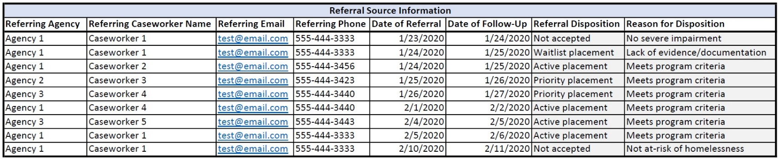
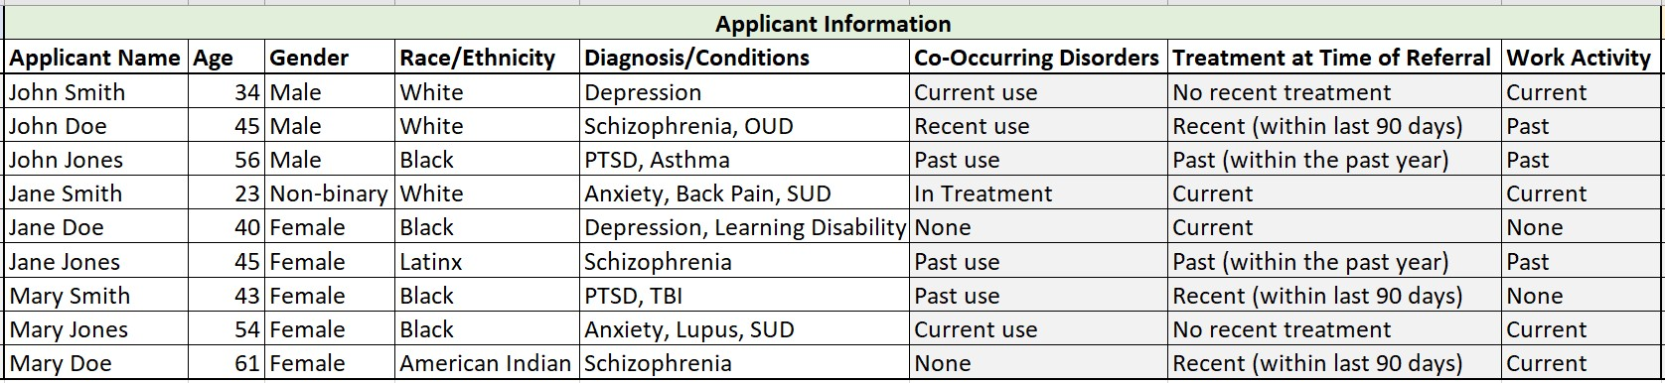
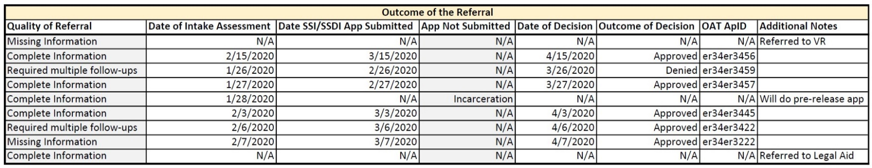
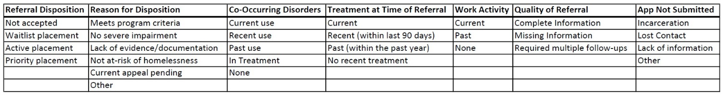
Pick-lists available for certain data elements:

