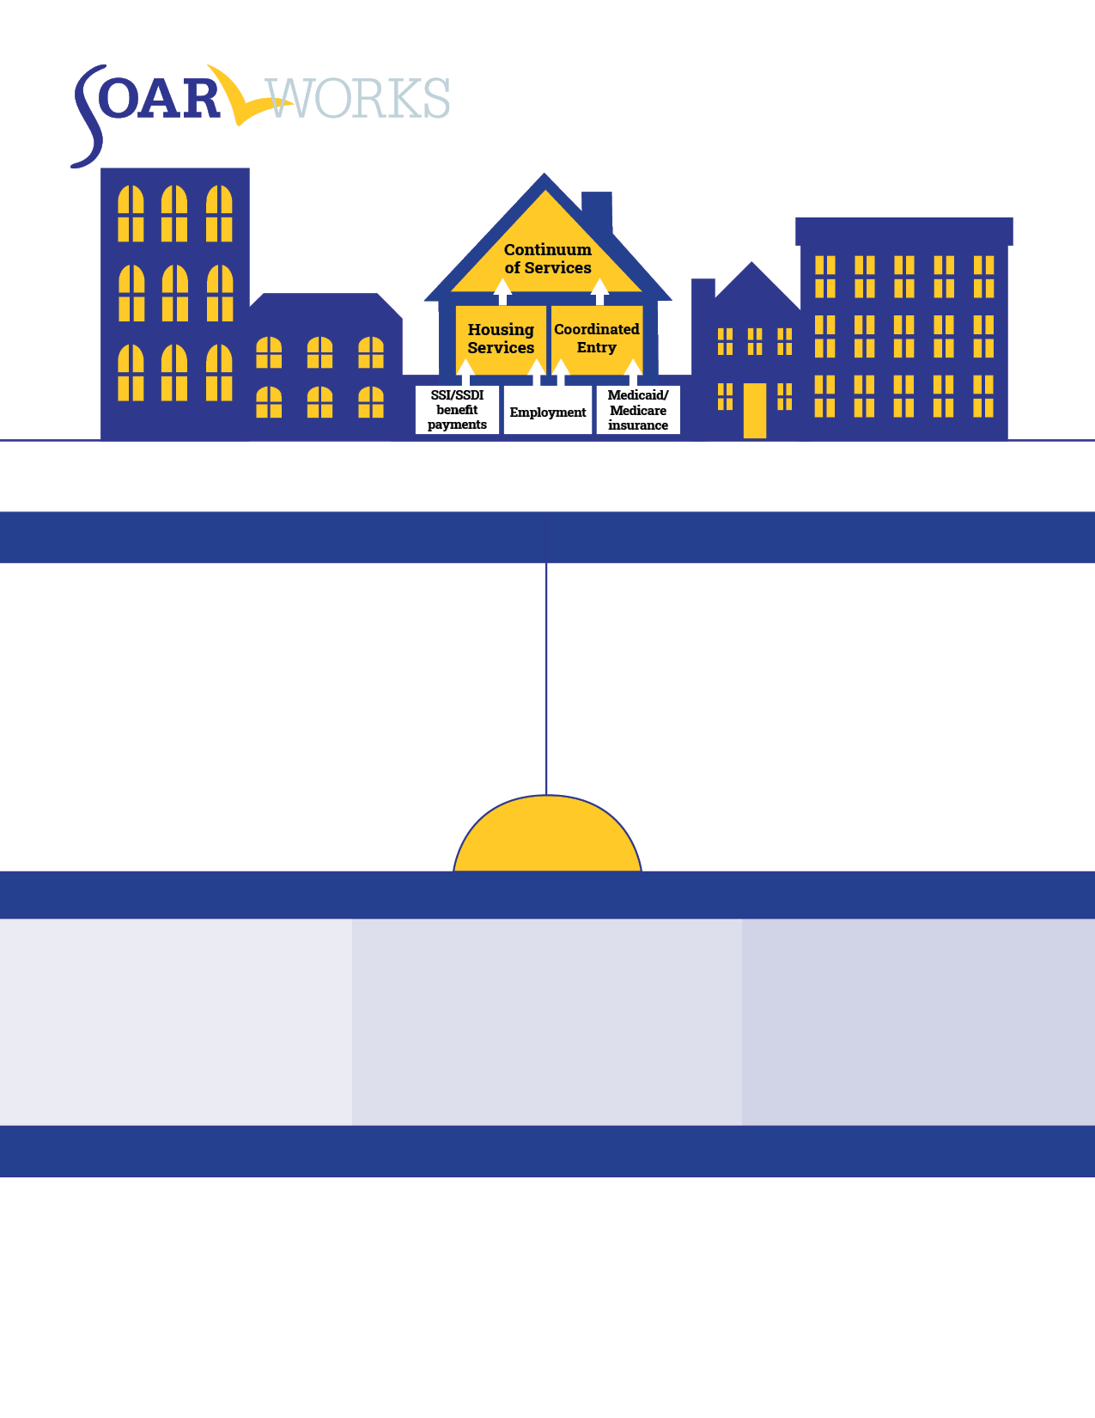

over $600,000 in back pay and monthly benefits

**$600,000**

assistance to over 50 eligible adults

**50**

42 families were connected with disability benefits

**42**

**HOW TO MAKE A REFERRAL**

**WHO IS ELIGIBLE**

**WHAT IS SOAR?**

**2021**

**PROGRAM HIGHLIGHTS**

SSI/SSDI Outreach, Access, and Recovery (SOAR) is a national program designed to increase access to the disability income benefit programs administered by the Social Security Administration (SSA) for eligible adults and children who are experiencing or at risk of homelessness and have a serious mental illness, medical impairment, and/or a co-occurring substance use disorder.

Eligible referrals must be a veteran or military spouse, have a confirmed medical impairment or mental illness that prevents gainful income, and be experiencing or at risk of homelessness.

**XYZ COMMUNITY MENTAL HEALTH**

SOAR State and Agency logos here:

Make a referral and contact SOAR! | EMAIL: [soar@prainc.com](mailto:soar@prainc.com) | PHONE: (518) 439-7415 | WEBSITE: soarworks.samhsa.gov

SSI/SSDI Outreach, Access, and Recovery (SOAR) is a national program designed to increase access to the disability income benefit programs administered by the Social Security Administration (SSA) for eligible adults and children who are experiencing or at risk of homelessness and have a serious mental illness, medical impairment, and/or a co-occurring substance use disorder.