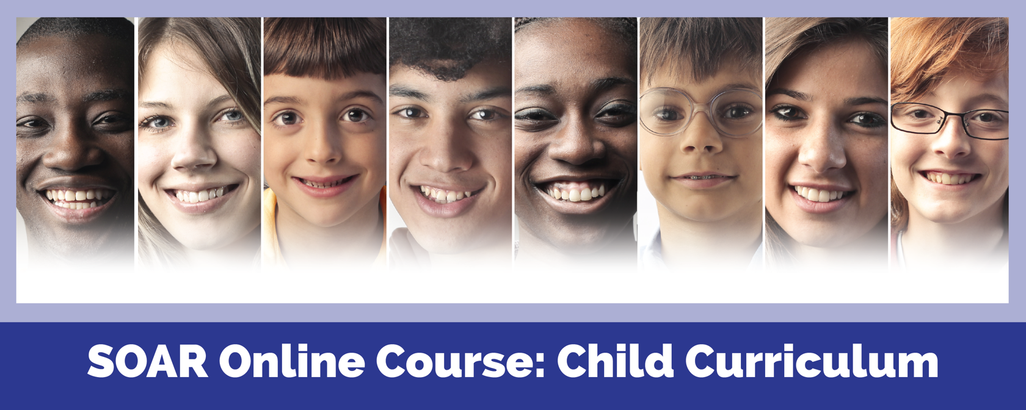

SOAR is a national program, sponsored by the Substance Abuse and Mental Health Services Administration (SAMHSA), designed to increase access to the disability income benefit programs administered by the [Social Security Administration (SSA)](http://www.ssa.gov/)for eligible adults and children who are experiencing or at risk of homelessness and have a serious mental illness, medical impairment, and/or a co-occurring substance use disorder.

**Supplemental Security Income (SSI) for Children:**

Developmental disabilities, serious mental illness, trauma, and medical issues can impact a child’s ability to function. Building resiliency and recovery can be extraordinarily challenging when a family is struggling to meet basic needs. Accessing income and healthcare benefits for children with disabilities through SSI is often a crucial first step to maximizing resiliency.

* Course is FREE, web-based, and self-guided
* Complete a full, practice SSI application for a fictional child, including a Medical Summary Report
* Receive individualized feedback from experts at the SAMHSA SOAR TA Center on the practice SSI application
* Training takes approximately 20 hours to complete
* Earn 20 free Continuing Education Units from the National Association of Social Workers upon successful completion
* Support available from the SAMHSA SOAR TA Center and local SOAR Leaders





**Enroll today!** https://soarworks.prainc.com/content/soar-online-course-catalog